APPENDIX E

PERT Diagram.

124

A + B + C + D + E + F + G = 35 weeks

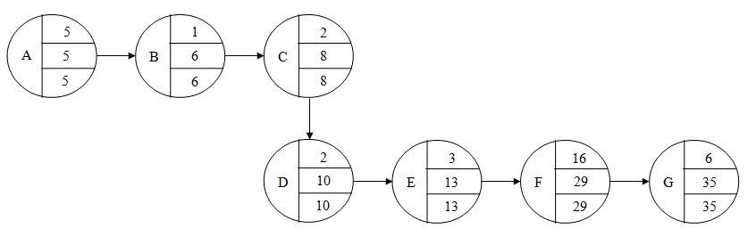

Critical Path: